

Dr. Jared, Jenkins inc.
2015-12-26
Dr. Jenkins
PSC 5031, Box 0142, APO AE 89111
Phone: 9122621558
Fax: 1681052605

Re: Olivia, Jones
PHN: 8105142297
Birthdate: 21-Aug-1952
Address: 551 Garcia Valley, Lake Rebecca, MI 96438
Patient number: 4470302403

To Whom It May Concern:

This is a medical letter to state the above patient is pregnant with expected delivery date of 16-Mar-2025. Hoping this information is satisfactory for your requirements.

Thank you.

Sincerely,
Dr. Jared, Jenkins
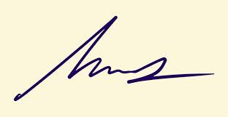
FRCS© NCMP
Clinical Assistant Professor, UBC
Department of Obstetrics and Gynecology SMH

